# Personal CV

**Personal information**

Name: Zixin Ding

Student ID: 20513868

Year: year 3

Major: CS (4+0)

Mobile phone number: 13378716480

Email: [ssyzd4@nottingham.edu.cn](mailto:ssyzd4@nottingham.edu.cn)

**Researching interest:**

1. Data science
2. Data analysis and mining
3. Big data
4. Database

**Academic Qualification:**

1. Language: C, Python, Java, HTML, CSS, SQL.
2. a little bit of machine learning (Data classification clustering, neural networks, etc).
3. Data visualization: Excel and Tableau, python and MATLAB
4. Data Science: Numpy, Pandas

**Summer school experience:**

2023 NUS Soc Summer school: Big Data Analytics and Visualizations

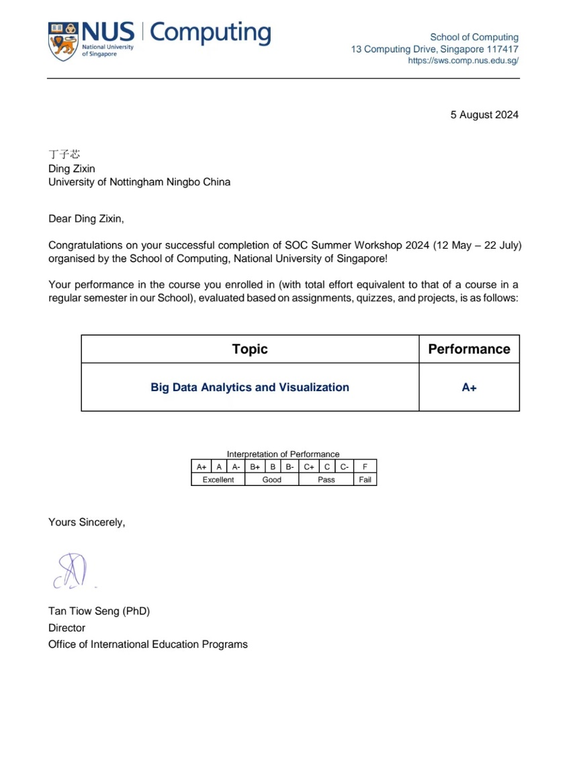

**Scientific research experience:**

2024 July - September: Data processing for Suzhou University Group

**Future research direction and field:**

1. Data Science and Big Data
2. Software Engineering